AI-POWERED BANKING FINANCIAL ANALYSIS AGENT

Work flow image :
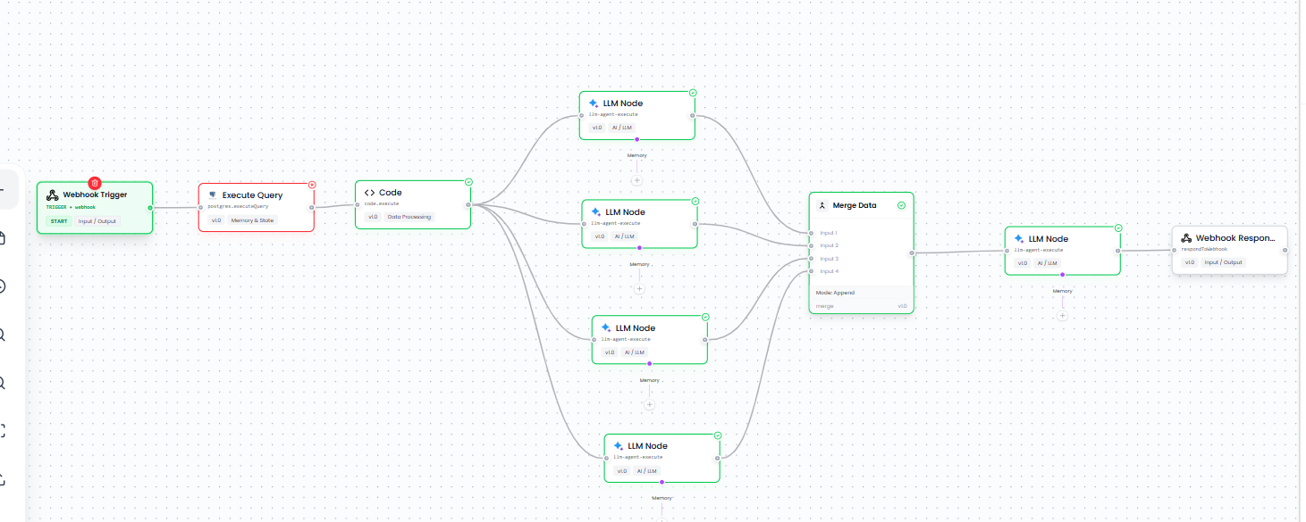

URL :
https://api.agents.snsihub.ai/webhook/dd177273-ec59-4344-91c2-df1efbb547ce

Process of this agent :
This is an AI-powered Banking Financial Analysis Agent that acts like a virtual financial analyst. Its main job is to take financial data of multiple banks, analyze their performance, compare them, identify risks, evaluate governance, generate investment recommendations, and finally produce one complete financial analysis report.
The purpose of this agent is to convert raw banking financial data into useful insights for analysts and decision-makers, reducing the need for manual financial comparison and analysis.
How the Agent Works and What Each Node Does
- Webhook Trigger — This is the starting point of the agent. The backend calls this webhook to start the analysis process. It can receive information such as the banks that need to be analyzed.
- Execute Query Node — Retrieves the required financial data of the banks from the database. This provides the source data needed for analysis.
- Code Node — Cleans, organizes, and structures the retrieved financial data into a format that the AI nodes can easily understand and process.
- LLM 1 – Peer Comparison Agent — Compares the banks against each other based on profitability, ROA, ROE, NPAs, capital adequacy, market position, assets, income, and other financial indicators. It identifies the industry leader, ranking, strengths, and weaknesses of each bank.
- LLM 2 – Transparency & Governance Agent — Evaluates the governance quality, transparency, disclosures, governance strengths, weaknesses, and red flags of each bank. It identifies which bank has the strongest and weakest governance.
- LLM 3 – What-if Analysis Agent — Performs stress testing and scenario analysis. It determines how the banks could perform under situations such as higher interest rates, economic slowdown, increasing credit risk, and other challenging conditions. It identifies which banks are more resilient and which carry higher risk.
- LLM 4 – Investment Recommendation Agent — Uses the financial information to generate a recommendation such as BUY, HOLD, or SELL, along with confidence level, risk level, investment horizon, reasons for the recommendation, major risks, and future outlook.
- Merge Data Node — Collects the outputs generated by LLM 1, LLM 2, LLM 3, and LLM 4 and combines them so they can all be provided to the final report generator.
- LLM 5 – Final Report Generator — Takes all four analyses and creates one consolidated banking financial analysis report containing the executive summary, bank rankings, peer comparison, governance analysis, stress analysis, investment recommendations, sector outlook, top recommended bank, highest-risk bank, and final conclusion.
- Webhook Response — Sends the final generated report back to the backend, where it can be stored in the database and displayed in the analyst portal/dashboard.
In simple words
The agent receives bank financial data → prepares the data → compares the banks → checks governance → checks risks under different scenarios → gives investment recommendations → combines everything → generates one final report → sends that report to the backend for storage and display.
So, essentially, this agent automates the work of a banking financial analyst and produces decision-ready insights from raw financial data.

